Investigating the Factors Influencing Intermediaries’ Performance: An Empirical Study Using Factor Analysis and Structural Equation Modelling

Anjali Patel^{1*} and Prof. (Dr.) Kedar Shukla²

^{1*}Research Scholar, Gujarat Technological University, Ahmedabad, Gujarat
² Professor and Director, GRIMS ROFEL MBA College, Vapi, Gujarat

Received: 01/10/2025  Revised: 09/10/2025  Accepted: 25/10/2025  Published: 11/11/2025 | ABSTRACT  To enhance financial protection and promote economic inclusion among the weaker sections of society, the social security schemes such as Pradhan Mantri Jeevan Jyoti Bima Yojana, Pradhan Mantri Suraksha Bima Yojana, and Atal Pension Yojana have been designed by the Government of India. However, despite their affordability and accessibility, these schemes continue to face implementation challenges. The present study investigates the underlying difficulties encountered in selling social security schemes by employing a quantitative framework based on factor analysis and Structural Equation Modelling (SEM). Primary data collected from 300 respondents were analysed using descriptive and inferential statistical methods. Three major dimensions emerged, with 76.93% of total variance that is Awareness & Literacy Barriers, Operational & Institutional Challenges, and Policy & Structural Constraints. According to SEM results, all these dimensions have a significant contribution towards improving intermediaries' performance in selling social security schemes. The study found that policymakers and institutions should work together to strengthen skills, improve policies, and streamline operations to enhance intermediaries’ performance. The study provides useful evidence for service providers to create more effective awareness programs, strengthen institutional support, and streamline operational processes to improve the adoption and sustainability of social security schemes among weaker sections of society.  Keywords: Social Security Schemes, Challenges, Structural Equation Model, Factor Analysis, Pradhan Mantri Jeevan Jyoti Bima Yojana, Pradhan Mantri Suraksha Bima Yojana, Atal Pension Yojana.

© 2025 by the authors; licensee Advances in Consumer Research. This article is an open access article distributed under the terms and conditions of the Creative Commons Attribution (CC-BYNC.ND) license(http://creativecommons.org/licenses/by/4.0/).

INTRODUCTION
Social Security Schemes are an important component of financial inclusion policies. They protect individuals against economic risks such as illness, accidents, unemployment and old age. In India, the government had initiatives like life and accident insurance programs and financial security during retirement age to extend financial security to the weaker sections of society. These Social Security Schemes are designed to reduce vulnerability and support long-term financial resilience. However, despite the affordability and accessibility of the schemes, the participation level remains modest, particularly among weaker sections of society.

The slow acceptance of Pradhan Mantri Jeevan Jyoti Bima Yojana, Pradhan Mantri Suraksha Bima Yojana, and Atal Pension Yojana reflects major constraints in the implementation of schemes. Many potential beneficiaries might have limited awareness of the schemes, a wrong perception of insurance and a misconception about their benefits. Even a lack of financial knowledge and trust further discourages enrolment in the schemes. At the same time, intermediaries face significant constraints such as low incentives, weak institutional support, inadequate training or complicated claim settlement procedures. These obstacles make it difficult to promote the schemes effectively and reach the target population.

Understanding these factors is essential to improving implementation and enhancing policy outcomes. The study aims to identify the key factors that influence the intermediaries in selling social security schemes. The present study aims to examine the factors being faced by the intermediaries in selling social security schemes with respect to the South Gujarat regions, which provide valuable insights for Service Providers, thereby increasing the reach, adoption, and sustainability of social security schemes.

LITERATURE REVIEW
Social Security Schemes are a crucial component of financial inclusion, offering economic protection and stability to weaker sections of society. However, the implementation of such schemes faces challenges, particularly in developing countries like India. Substantial studies have focused on the challenges associated with the implementation of social security schemes. The demand side factors, such as less awareness and limited financial literacy, and supply side factors, including inefficiencies, operational and insufficient institutional support, have been highlighted by the researchers as challenges for social security schemes (Annamalai & Bhagat, 2020).

In the adoption of Social Protection, the several studies have explored the role of financial knowledge and awareness play a crucial role in promoting participation and effective implementation. Allen et al. (2016) signify that the lack of financial literacy directly affects the individual's ability to participate in formal financial systems. Similarly, Bhanot et al. (2012) found that insufficient comprehension of insurance benefits reduces the rates of enrolment in rural areas. Singh and Kaur (2023) highlight that even with government-backed schemes, awareness campaigns often fail to reach the target population effectively, leading to misconceptions and mistrust among people.

From the perspective of the supply side, the operational constraints remain significant. The researchers Thampy & Rao (2019) found that agents encounter difficulties in the collection of premiums, poor training, and low incentives, which decreases their motivation level to sell microinsurance products. Churchill and Matul (2012) also assert that limited reinsurance support, complex claim procedures, and inadequate digital infrastructure make scheme administration complicated. Subrahmanyam & Thakur (2021) recognised that the weak mechanisms and inconsistent monitoring hinder the long-term sustainability of social security schemes. Globally, the World Bank report (2020) have signified that microinsurance and social protection initiatives must balance accessibility and sustainability. Although earlier studies have examined the demand and supply side challenges, there is limited evidence integrating these dimensions into a comprehensive model. The prior studies used descriptive analyses, less advanced techniques such as Factor Analysis or Structural Equation Modelling to examine the interrelationship among key factors that were not measured. The present study addresses this gap by forming an integrated model of the challenges faced in selling social security schemes.

Research Objectives
The Study aims to investigate the major factors faced by intermediaries in selling social security schemes and to model the underlying factors influencing intermediaries’ performance by using advanced statistical techniques.

RESEARCH METHODOLOGY
This study adopts a quantitative Research design to investigate the major factors faced by the intermediaries in selling social security schemes. The study is based on Primary data gathered from 300 respondents through structured questionnaires administered to intermediaries in promoting social security schemes such as Pradhan Mantri Jeevan Jyoti Bima Yojana, Pradhan Mantri Suraksha Bima Yojana and Atal Pension Yojana. The questionnaires included 13 indicators based on a Likert scale related to operational challenges identified by earlier studies and a pilot test for content validity.

For statistical analysis, the researcher utilised IBM SPSS Statistics version 26.0 for processing descriptive statistics, factor analysis and inferential statistics. Additionally, Structural Equation Modelling (SEM) through IBM SPSS AMOS Graphics 26 was used to test the hypothesised relationship among the identified dimensions contributing towards improving intermediaries' performance.

Data Analysis and Interpretation
The frequency distribution of the study discloses that most respondents rated financial illiteracy, lack of awareness, difficulty in convincing the customers, claim settlement delays and digital issues as major and significant factors. This indicates that these factors are commonly experienced and affect intermediaries' performance. Descriptive statistics show mean scores ranging between 3.5 and 3.8, suggesting respondents consider all these variables as significant challenges. The Principal Component Analysis with varimax rotation identified three significant components that collectively explain the major factor influencing the performance of intermediaries in selling social security schemes. The KMO measure of sampling adequacy shows the value of the test statistic as 0.836 was taken as acceptable, and Bartlett’s test was significant with p = 0.000, being less than 0.05. The variable which emerges in the respective factors are shown in the rotated components matrix table, which explain the variable loading in each factor.

The first set of factors encompasses financial illiteracy (0.861), lack of awareness among people (0.843), difficulty in convincing the customers (0.790), low-income market (0.721), competition from private insurance (o.641), and misconception about insurance (0.620). These indicators were named Awareness & Market Perception, which highlight that low financial awareness, customer misconceptions, and market competition slow down intermediaries’ outreach and performance. The second set of factors includes customer expectations of benefits even if no claim occurs (0.850), claim settlement delays (0.849) and overlap between Schemes (0.609), and it was named as Policy and Procedural factors, which reflects policy-level, claim-related inefficiencies and an insufficient motivational framework that restricts the intermediary’s efficiency. The third set of factors includes technical and digital issues in enrolment (0.842), lack of promotional material (0.806), insufficient training (0.613) and lack of incentives and recognition for intermediaries and was named as operational factors.

Collectively, these three factors, which are Awareness & Market Perception, Policy and Procedural, and operational, represent the key factors shaping Intermediaries’ Performance.

Table 1: Rotated Component Matrix
Rotated Component Matrixª
Factors | Component
Factors | 1 | 2 | 3
Financial Illiteracy | 0.861
Lack of awareness among people | 0.843
Difficulty in convincing | 0.79
Low-Income Market | 0.721
Competition from Private Insurance | 0.641
Misconceptions about Insurance | 0.62
Customers expect benefits even if no claim occurs |  | 0.85
Claim Settlement Delays |  | 0.849
Overlap between Pradhan Mantri Insurance Scheme and Micro Insurance Product |  | 0.609
Technical and Digital issues in enrolment |  |  | 0.842
Lack of Promotional Material and support from the Government |  |  | 0.806
Insufficient Training for Intermediaries |  |  | 0.613
Lack of Incentives and recognition for intermediaries |  |  | 0.607
Extraction Method: Principal Component Analysis.
Source: SPSS Output
Figure 1: Structural Model of Factors Influencing Intermediaries’ Performance

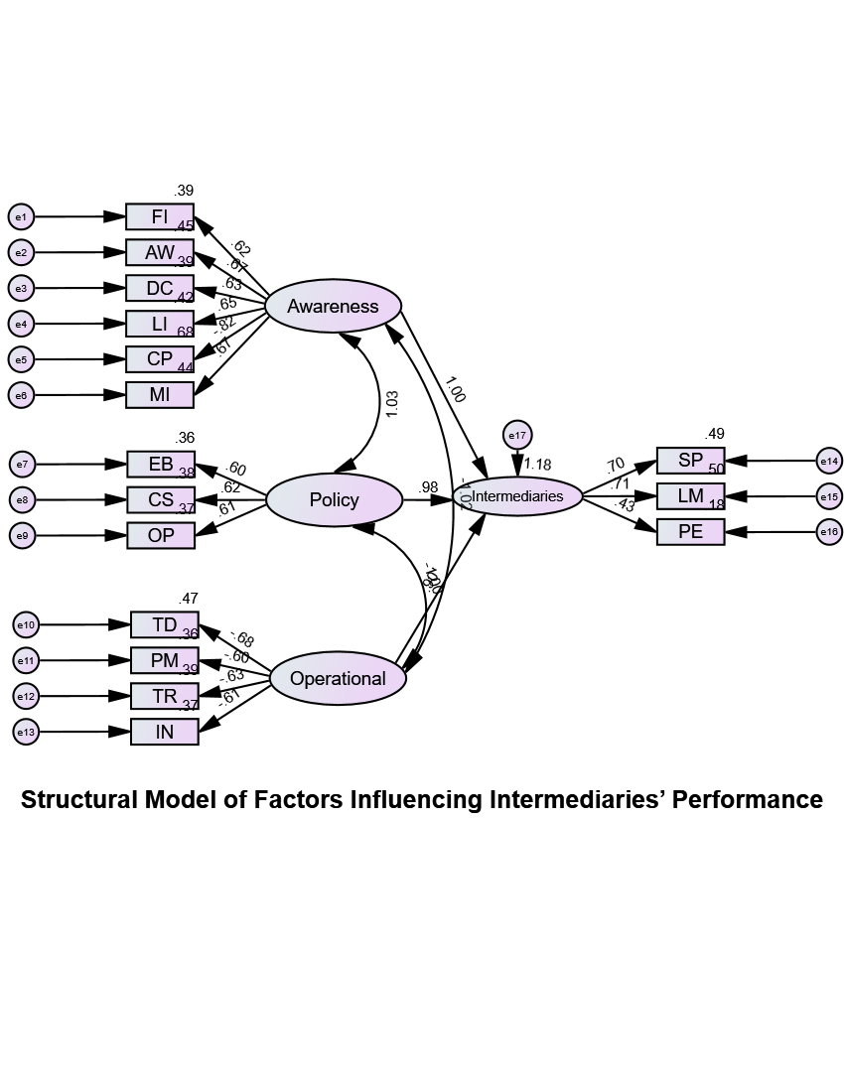

Table 2: Fitness of the Model
Name of Index | Value | Acceptable Rage | Interpretation
Chi-square/df | 1.757 | < 3.00 | Excellent Fit
Goodness of Fit Index (GFI) | 0.934 | ≥ 0.90 | Good Fit
Adjusted Goodness of Fit Index (AGFI) | 0.912 | ≥ 0.90 | Good Fit
Comparative Fit Index (CFI) | 0.961 | ≥ 0.90 | Excellent Fit
Tucker Lewis Index (TLI) | 0.955 | ≥ 0.90 | Excellent Fit
Incremental Fit Index (IFI) | 0.962 | ≥ 0.90 | Excellent Fit
Normed Fit Index (NFI) | 0.915 | ≥ 0.90 | Good Fit
Root Mean Square Error of Approximation (RMSEA) | 0.05 | < 0.08 | Excellent Fit
Standardized Root Mean Residual (RMR) | 0.092 | < 0.08 | Acceptable Fit
Parsimony Goodness Fit Index (PGFI) | 0.701 | > 0.50 | Acceptable Fit
Parsimony Normed Fit Index (PNFI) | 0.778 | > 0.50 | Acceptable Fit
Parsimony Comparative Fit Index (PCFI) | 0.817 | > 0.50 | Acceptable Fit
Source: AMOS Output

The Structural Equation Modelling results provide empirical support for the proposed framework, examining the determinants of Intermediaries’ Performance. The Measurement and Structural Model fit indices a satisfactory level of model adequacy as the chi-square value was 1.947, comparative fit index (CFI = 0.957) and Goodness of fit Index (GFI = 0.934) fall within the accepted range for SEM, thereby asserting the credibility of the specified model structure. The result shows that the awareness and market perception, policy and procedural and operational dimensions have significant and positive effects on intermediaries’ performance. Among the three Predictors, policy and operational factors demonstrated comparatively stronger effects, highlighting their crucial role in driving intermediary efficiency. Practically, the findings suggest that policymakers and institutions should work together to strengthen skills, improve policies, and operations to enhance intermediary performance.

Findings of the Study
The frequency distribution found that financial illiteracy, lack of awareness, difficulty in convincing customers, claim settlement delays and digital issues were considered to be major and significant challenges. The three major components found were named as awareness & Market Perception, Policy & Procedural and operational based on factor loading through Principal Component Analysis. Through SEM, it was confirmed that Awareness & Market Perception, Policy & Procedural Factors and operational factors all had significant and positive impacts on the performance of intermediaries.

CONCLUSION
The study concludes that the performance of the intermediary in selling social security schemes is influenced by three interrelated dimensions, which are Awareness & Market Perception, Policy & Procedural Factors and operational factors. A lack of awareness among people and having customer misconceptions can hinder the efforts to outreach, while procedural inefficiencies and limited support from operational mechanisms further constrain the performance of Intermediaries. Strengthening these dimensions can significantly enhance the efficiency and performance of intermediaries and thereby improve the outreach and success of social security schemes among the public.

REFERENCES
- Allen, F., Demirgüç-Kunt, A., Klapper, L., & Peria, M. S. M. (2016). The foundations of financial inclusion: Understanding ownership and use of formal accounts. Journal of Financial Intermediation, 27, 1–30. https://doi.org/10.1016/j.jfi.2015.12.003
- Annamalai, T., & Bhagat, M. (2020). Barriers to microinsurance penetration in India: An empirical perspective. International Journal of Social Economics, 47(2), 185–202. https://doi.org/10.1108/IJSE-06-2019-0397
- Bhanot, D., Bapat, V., & Bera, S. (2012). Exploring financial inclusion trends in North-East India. International Journal of Bank Marketing, 30(6), 465–484. https://doi.org/10.1108/02652321211262221
- Churchill, C., & Matul, M. (2012). Protecting the poor: A microinsurance compendium (Vol. 2). International Labour Organisation.
- Morduch, J. (2006). Microinsurance: The next revolution? In A. V. Banerjee, R. Benabou, & D. Mookherjee (Eds.), Understanding Poverty (pp. 337–356). Oxford University Press.
- Singh, R., & Kaur, J. (2023). Awareness and satisfaction of beneficiaries under Indian social security initiatives. Asian Journal of Economics and Empirical Research, 10(1), 20–31.
- Sinha, S., & Kanbur, R. (2022). Social protection and informal sector workers in India: Challenges and policy directions. Development Policy Review, 40(1), e12567. https://doi.org/10.1111/dpr.12567
- Subrahmanyam, G., & Thakur, R. (2021). Customer perception towards Pradhan Mantri insurance schemes: Evidence from Gujarat. Journal of Insurance and Financial Management, 4(2), 65–83.
- Swamy, V. (2014). Financial inclusion, gender perspectives, and the economic well-being of poor households. World Development, 56, 1–15. https://doi.org/10.1016/j.worlddev.2013.10.019
- Thampy, A., & Rao, S. (2019). Barriers encountered by field agents in promoting microinsurance: Evidence from India. Journal of Development Policy and Practice, 4(1), 72–89. https://doi.org/10.1177/2455133319830262
- World Bank. (2020). Global financial inclusion and consumer protection survey 2020: Trends in microinsurance and social protection. World Bank Publications.

